Technology Acceptable Use Policy Attestation

With your signature you are attesting to the following:

I have read, understand, and agree to comply with, and abide by the provisions set forth in this Technology Acceptable Use Policy of the Concho Elementary School District #6 (required by all staff and all students)

Parents of students in grades 1 and 2 are required to fill out and sign this agreement for their student.

Student/Staff Name (print):__________________________________________________
Signature: __________________________________________________________
Grade/Position: __________________________________________________________
Date:

In addition, for students under the age of 18, parent or legal guardian must sign

Parent/Guardian (print): _____________________________________________
Signature: _____________________________________________
Date:

Employee (print): _____________________________________________
Signature: _____________________________________________
Date:

Students: Return this form to the front office

Employee: Return this form to the administrator’s office

This page left intentionally blank

Concho Elementary School District #6

Technology Acceptable Use Policy

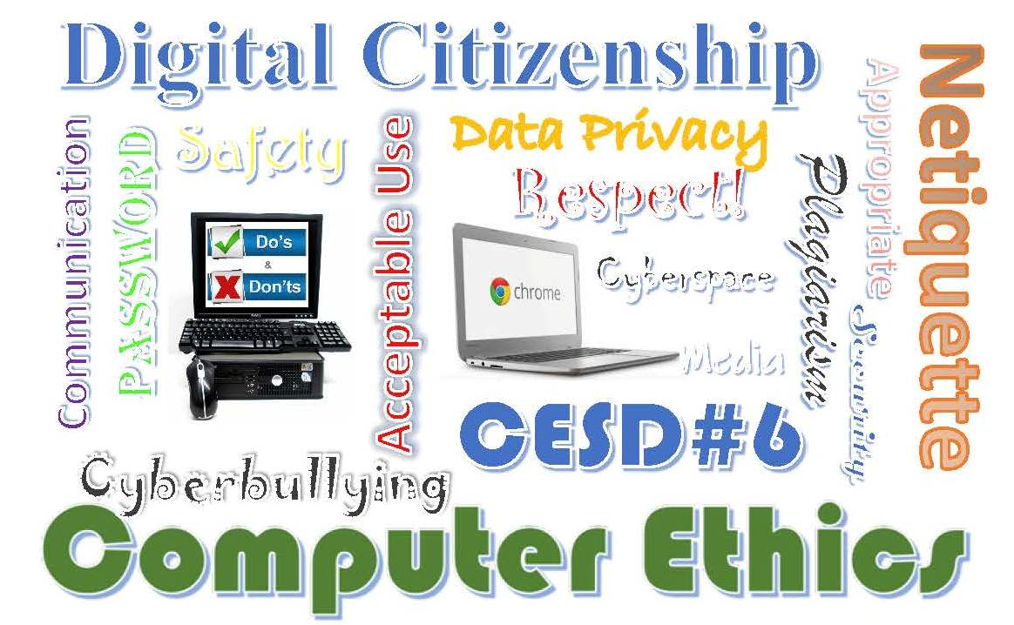

Updated July 2026

This page left intentionally blank

Purpose
The purpose of this Technology Acceptable Use Policy (TAUP) is to clarify the use of District technology resources for the staff and students of Concho Elementary School District #6. This policy applies to all students, staff and others having access to the District network (users). While this policy is NOT intended to prohibit or discourage use of the Internet or resources, it is designed to protect the users and the District against potential liability, security threats and vulnerabilities.

Student, Parent/Legal Guardian, and Staff User Agreement
The District provides students with a variety of technology resources, including electronic devices, software, and means of electronic communication. The District believes the resources available offer significant opportunities for teaching and learning; however, the technology must be used in a responsible manner. While the District provides protection from harmful material through the use of filtering software, the teacher and the student have the ultimate responsibility for using the technology according to District guidelines and policy.

Terms and Conditions

Unacceptable Use

Students are responsible for their own actions involving District technology, along with personal files, passwords, and accounts. Uses and activities that are expressly prohibited include:

- accessing or downloading VPNs or other proxy-avoiding extensions with the intent of bypassing District security features and filtering;
- accessing, submitting, transmitting, posting, publishing, forwarding, downloading, scanning, or displaying materials that are defamatory, abusive, obscene, vulgar, sexually explicit, sexually suggestive, threatening, discriminatory, harassing, and/or illegal;
- soliciting or distributing information with the intent to threaten, harass, or bully others;
- using District technology for any illegal activity or activity that violates other Board policies, procedures, and/or school rules;
- copying or downloading copyrighted materials, including software, without the permission of the copyright owner or express authorization of the student’s teacher or principal;
- representing as one's own work any materials obtained on the internet, including information provided by artificial intelligence (AI), such as term papers and articles (when internet sources are used in student work, the author, publisher, and website must be identified);
- sharing passwords, using other users' passwords without permission, and/or accessing other users' accounts;
- any malicious use, disruption, or harm to the school's technology devices, networks, and internet services, including, but not limited to, hacking activities and creating or uploading malware;
- accessing social networks without specific authorization from the supervising teacher; and
- misuse of a school name or logo on a personal website that gives the reader the impression that the website is an official school or District website.
- Bringing equipment from home and plugging it into the network without permission from, and a virus check completed by, the Computer Lab Teacher.
- Disclosing sensitive District information without documented authorization.
- Sending sensitive information over District resources without proper encryption and security.
- Soliciting emails that are unrelated to District business and education.
- Using the District network for commercial or financial gain.
- Representing personal views and opinions as those of the District.
- Downloading, installing, or copying software, apps or other files without authorization of the Administration and the Computer Lab Teacher.
- Downloading or copying materials or copyrighted information without permission.
- There will be no use of computer games, unless part of a teacher directed classroom lesson, during school hours (7:30am – 4:30pm).
- Intentionally damaging technology equipment, files, data or the network.
- Tampering with District computer security systems, applications, documents or equipment. This is considered vandalism, destruction, and defacement of school property.
- Attempting to circumvent or sabotage system security measures.
- Using computer programs to decode passwords or to access control information.
- Engaging in any activity that might be harmful to systems, the network, cloud resources or any information stored thereon, such as damaging files or disrupting service.
- Any use of technology deemed inappropriate by District Administrator or representative.

Students will be held accountable for completing assignments that require the use of computers even if their in-school computer access privileges are suspended or revoked.

The District retains control, custody, and supervision of all District technology. The District reserves the right to monitor student and/or employee usage of all District technology. Students and/or staff have no right of privacy in their use of District technology, including email and stored files.

Acceptable Use

Computers, laptops, and any other end user devices, Wi-Fi, the Internet and other technologies are to be used in a manner that is consistent with the District’s standard policies of conduct. The District will verify each academic year that employed staff and registered students in the District have a signature both for themselves and from a parent/guardian (for minors) on file acknowledging acceptance of this policy. The TAUP will remain in effect until the end of each academic school year, until the user is no longer a staff member or student of the District, or until privileges have been revoked due to violation of this policy. Please note that the District reserves the right to determine the appropriateness of all information accessed through its technology. The signer of this policy acknowledges and understands that the use of District technology shall include but not be limited to the following:

- Users may be subject to limitations imposed on use of any or all technology resources including but not limited to district/school computers, district network and cloud accounts, any end user devices, computer network, Wi-Fi access, inter/intranet, modular audio/visual tools, email, and telephone.
- All classroom use of technology including but not limited to Netbook carts, cameras, document cameras, media cart, that are not physically attached to the building, shall be checked out from the Computer Lab Teacher at the beginning of the year and back in at the end of the school year.
- Access to websites, email accounts, cloud accounts and other online media will not be used for anything other than District approved communications and learning.
- Computer usage, Internet/Intranet, and email are subject to monitoring and reporting for security and network management.
- Distribution of all information through the District network is subject to scrutiny by the authorized District personnel, as well as state and federal auditors.
- The District resources are subject to State and Federal laws and illegal use will be dealt with promptly and appropriately.

Artificial Intelligence (AI)

As emerging technologies like artificial intelligence (AI) and Natural Language Processing (NLP) become more prevalent, our District is proactively developing principles to guide the safe, effective, and responsible use of these tools for student learning.

Students are required to rely on their own knowledge, skills, and resources when completing school work. In order to ensure the integrity of the educational process and to promote fair and equal opportunities for all students, the use of Artificial Intelligence (AI) and Natural Language Processing (NLP) tools (collectively, “AI/NLP tools”) is strictly prohibited for the completion of school work except as outlined below. The use of AI/NLP tools, without the express permission/consent of a teacher, undermines the learning and problem-solving skills that are essential to academic success that instructional staff is tasked with developing in each student. Students are encouraged to develop their own knowledge, skills, and understanding of course material rather than relying solely on AI/NLP tools. Students should ask their teachers when they have questions and/or need assistance.

Unauthorized use of AI/NLP tools is considered a form of plagiarism, and any student found using these tools without permission or in a prohibited manner will be disciplined in accordance with the Student Code of Conduct.

Notwithstanding the preceding, students may use AI/NLP tools in the school setting if they receive prior permission/consent from their teacher, so long as they use the AI/NLP tools in an ethical and responsible manner.
Teachers have the discretion to authorize students to use AI/NLP tools for the following:

- Research assistance: AI/NLP tools can be used to help students quickly and efficiently search for and find relevant information for their school projects and assignments.
- Data analysis: AI/NLP tools can be used to help students analyze, understand, and interpret large amounts of data, such as text documents or social media posts. This can be particularly useful for research projects or data analysis assignments—e.g., scientific experiments and marketing research.
- Language translation: AI/NLP tools can be used to translate texts or documents into different languages, which can be helpful for students who are learning a new language or for students who are studying texts written in a different language.
- Writing assistance: AI/NLP tools can provide grammar and spelling corrections, as well as suggest alternative word choices and sentence structure, to help students improve their writing skills.
- Accessibility: AI/NLP tools can be used to help students with disabilities access and understand written materials. For example, text-to-speech software can help students with specific learning disabilities or visual impairments to read texts, and AI-powered translation tools can help students with hearing impairments understand spoken language.

Special Note – Cyberbullying

Cyberbullying is defined as the use of Internet and/or other technology resources to harass, embarrass, intimidate, hurt, or otherwise demean another individual, group, or entity. Any form of cyberbullying will be dealt with as a punishable breach of the District’s conduct policy and will subject the perpetrator to immediate disciplinary action up to including contacting law enforcement. Students in grades 3-8 will be required to participate in a cyberbullying curriculum approved by the District Administrator.

Cyberbullying includes but is not limited to:

- Bullying, harassing, threatening, or humiliating others using email, cloud resources, texting, social networking sites, any type of blog or interest group threads (anything that is/can be accessed by a computer or any end user devices, etc.), website, or telecommunication devices.
- Posting hurtful, negative, threatening, or embarrassing comments on these types of sites or via telecommunication.
- Logging into another person’s email account and/or posing as them to harass another person. This is a form of identity theft and is illegal!
- Substantially harass another or others which disrupts the learning environment on or off school property.

Penalties for Inappropriate Use

Misuse of the privilege to use District technology resources may result in possible disciplinary action, revocation of access to network and/or computers, and legal action for any and all users of the network and its resources. This action may include suspension or expulsion for students, dismissal from District employment for staff, and criminal prosecution by law enforcement. Severity of the actions taken by the District and/or government authorities will be based on the severity of the specific infraction(s) at the discretion of the District administration.

Privacy and Administrator’s Access to User Files

Since Concho Elementary School District is a public entity all records (excluding those
specified by law*), whether in electronic or hardcopy form, are subject to the Freedom of Information Act and open to public inspection. Network and cloud storage areas are subject to inspection. Network administrators may review communications (emails, attachments, files, etc.) to maintain integrity system-wide and ensure that users are using the system in a responsible, acceptable manner. Users should NOT assume that their use of the network or cloud resources are private. The district reserves the right to monitor network activity in any form that it sees fit to maintain system integrity, and to copy, examine, and delete any files or information on the network or cloud that may suggest that a student/staff member is using school computers systems inappropriately. All inappropriate use will be subject to disciplinary action at the discretion of the District Administrator and consistent with District conduct policy.

*FERPA (Family Educational Rights & Privacy Act: the federal law that protects the privacy of student education records. This law applies to all schools that receive funds under an applicable program of the U.S. Department of Education.) [20 U.S. C. &1232g; 34 CFR Part 99]

Information Technology Policy - Hardware, Software, and Data security

- Responsibility Hierarchy for decisions dealing with hardware, software, and data security:
  - District Administrator
  - Computer Lab Teacher
- Responsibility Hierarchy for directing and supervising the operation of district computer systems:
  - District Administrator
  - Computer Lab Teacher
- Data security, backups, and backup storage will be under the control of the Concho Elementary School District Computer Lab Teacher. When and if this changes the District Administrator will decide the details of reallocating responsibilities.
- Access to Intranet locations will be allocated by responsibility through membership in predefined groups. Administration of these groups will be the responsibility of the Computer Lab Teacher.
- AzEDS, student data as stipulated by Arizona Revised Statutes and district level student data will be the responsibility of the Front Office Manager. Assistance on dealing with irregularities in the data will fall to the Computer Lab Teacher or appropriate consultant/ADE staff member.
- Human resources data maintenance will be the responsibility of the District Administrator’s Administrative Assistant unless otherwise authorized by the District Administrator. Assistance in dealing with irregularities in the data will fall to the Computer Lab Teacher or appropriate consultant/ADE staff member.
- All staff members with access to the district domain will have a unique user name and password. Password changes will be prompted automatically a minimum of three times during the academic year. District Computer Lab Teacher will have access to password reset for both domain and cloud accounts (email).
- Access to personal student and staff information will have an additional layer of password protection over that of entry to the domain.
- Access to financial records will have an additional layer of password protection over that of entry to the domain.
- All changes in policy or responsibility for oversight will fall to the District Administrator.
- Decisions and implementation of this policy and any future changes must be reviewed by the District Administrator for final approval by the District Governing Board

Disclaimer

The District is not responsible for any claims, damages, losses, costs, or other obligations arising from the use of the District network and resources. The District is not responsible for Internet use outside the District network. The District makes no guarantees of the quality of services provided. All charges accrued by a user of the District network are solely the responsibility of the particular user, not the District. All thoughts, views and opinions accessed on the Internet using the District network are NOT the thoughts, views and opinions of the District, its staff or its students, but are understood to be that of the author(s) of such information.

Policy Changes

Changes to this policy during the academic year may be made at the discretion of the District Administrator. These will be reviewed at the Technology Committee meeting schedule following the change for inclusion to the TAUP.

Check Your Understanding of the Technology Policy
Name _______________________________ Grade

Who does the Technology Policy cover? Where can you find that information (pg/s)?

What is one penalty for using the technology inappropriately? Where can you find that information (pg/s)?

What is Cyber Bullying? Where can you find that information (pg/s)?

Is the use of Artificial Intelligence (AI) allowed in school? Where is that information found (pg/s)?

Who is allowed to update or change the Technology Policy? Where is that information found (pg/s)?

If you have answered these questions, please hand in to the front office.

This page left intentionally blank

